Class 362 SWE Fundamentals

---------------------------------------

Team JAH & Members

=================

- John Margis

- Anette Ulrichsen

$VCS Project 2 – Checked

===========================

- This Project 2 creates a repository root folder by replicating an entire source tree,

given the source and target paths. On doing so it creates a manifest listing the

command particulars, the date and time of the command. Each project source file

line gives a small description of what is inside along with the project folder relative

path. We also include an artifact ID with full file contents under a leaf folder, which

includes the file’s name. It also includes a label function that, given a manifest name and a target path, can create a new label, or given an established label name and target path, can create a new label. There is a check in function, which overwrites the current version of the repo from the project tree and generates a new manifest file. There is also a check out function, that creates a new repository based on a manifest file inside of the source repository.

File Includes With This Project

========================

- artifact.cpp Artifact implementation

- artifact.h Artifact header

- file.cpp File implementation

- file.h File header

- leaf.cpp Leaf implementation

- leaf.h Leaf header

- main.cpp Driver for create repo

- manifest.cpp Manifest implementation

- manifest.h Manifest header

- repo.cpp Repo implementation

- repo.h Repo header

- README This file

External Requirements

==================

NONE

Setup & Installation

===============

-This program does not require installation.

You should run the program in any C++ compiler or Linux device.

Features

=======

- When compiling and running the C++ files it requires C++17 standards, which this

program implements new features used up to C++17. Visit:

https://en.cppreference.com/w/cpp/compiler_support

- When compiling and running in Linux make sure to add –lstdc++fs option

Visit: https://stackoverflow.com/questions/44476810/build-project-with-

experimental-filesystem-using-cmake

Sample invocation & Results To See

===========================

- After Setup & Installation and Features added to user device you will be able to run

the program.

- First thing you will see:

COMMANDS:

create

check-in

check-out

label

ENTER A COMMAND:

You can type an of the above commands to run. Create creates a repository from a project tree. Check in overwrites a repo from the project tree. Check out generates an older version of the repo from a manifest file. Label finds and adds a label inside of a repo manifest file. The program only runs once. If you would like to use multiple commands, you must run it multiple times.

**CHECKOUT SAMPLE:** 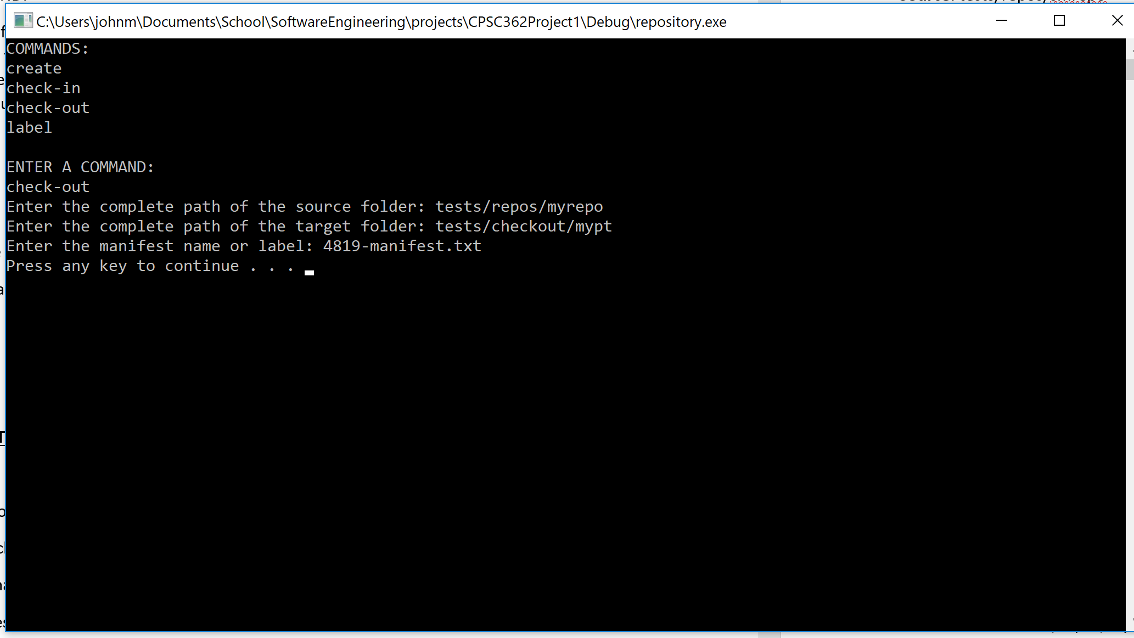

- Result should be a repository copy of the source tree, including an artifact under a

leaf folder and manifest for command particulars.

**CHECK-IN SAMPLE:**

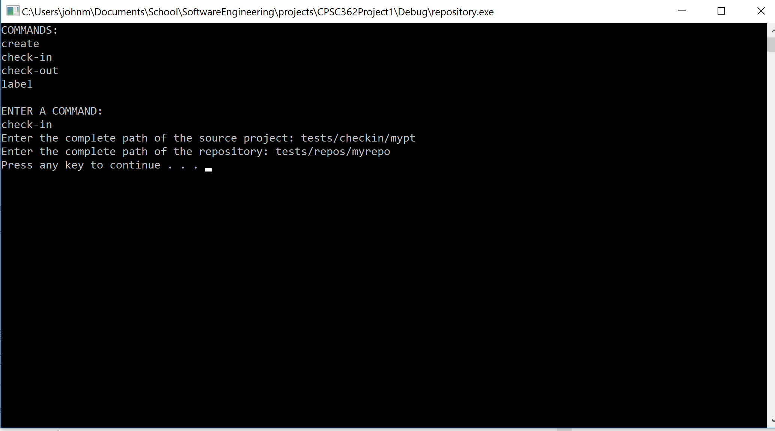

* Result should be an updated repository at the target path, created from the project tree in the source path.

**LABEL SAMPLE:**

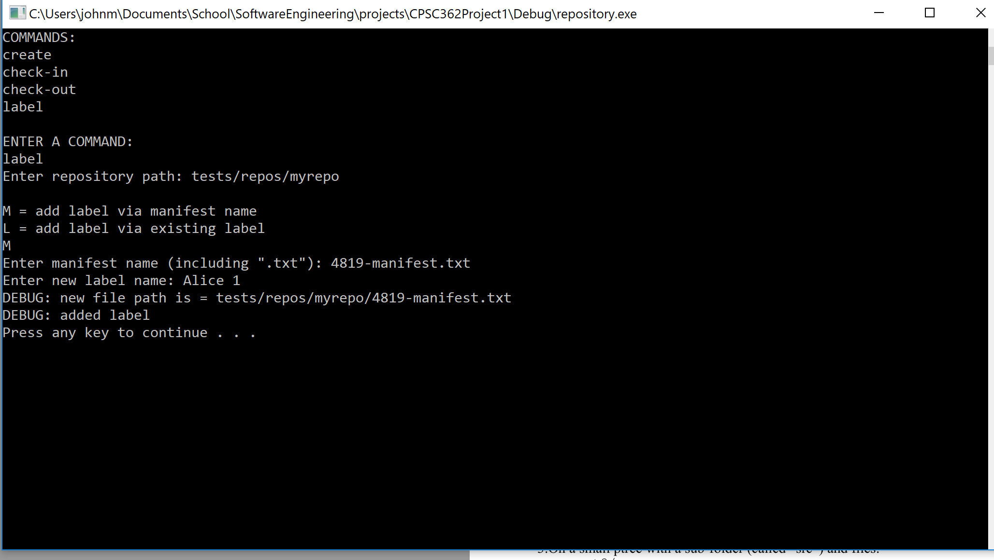

* Result should append L: LABEL NAME to the manifest and allow selection by label.

**TEST CASE DIRECTORY LISTINGS:**

Note: Test case results located in tests folder within ZIP file.

***CHECKOUT***:

**Source**: tests/repos/myrepo

**Target**: tests/checkout/mypt

**Manifest**: 4819-manifest.txt

**NEW Manifest:** tests/checkout/6282-manifest.txt

**Source**: tests/repos/myrepo2

**Target**: tests/checkout/mypt2

**Manifest**: 4957-manifest.txt

**NEW Manifest:** tests/checkout/6397-manifest.txt

**Source**: tests/repos/myrepo3

**Target**: tests/checkout/mypt3

**Manifest**: 4993-manifest.txt

**NEW Manifest:** tests/checkout/6465-manifest.txt

**Source**: tests/repos/smrepo

**Target**: tests/checkout/smpt

**Manifest**: 5048-manifest.txt

**NEW Manifest:** tests/checkout/6518-manifest.txt

**Source**: tests/repos/smrepo2

**Target**: tests/checkout/smpt2

**Manifest**: 5162-manifest.txt

**NEW Manifest:** tests/checkout/6576-manifest.txt

***CHECKIN***:

**Source**: tests/checkin/mypt

**Target**: tests/repos/myrepo

**NEW Manifest:** tests/repos/myrepo/7314-manifest.txt

**Source**: tests/checkin/mypt2

**Target**: tests/repos/myrepo2

**NEW Manifest:** tests/repos/myrepo2/7363-manifest.txt

**Source**: tests/checkin/mypt3

**Target**: tests/repos/myrepo3

**NEW Manifest:** tests/repos/myrepo3/7409-manifest.txt

**Source**: tests/checkin/smpt

**Target**: tests/repos/smrepo

**NEW Manifest:** tests/repos/smrepo/7451-manifest.txt

**Source**: tests/checkin/smpt2

**Target**: tests/repos/smrepo2

**NEW Manifest:** tests/repos/smrepo2/7497-manifest.txt

Bugs

====

- When creating repo, you cannot create it in the same place as the source file.

- If a repo is created using an absolute path, check-in and check-out commands must also use an absolute path.

-If a repo is created using a relative path, check-in and check-out commands must also use a relative path.